REPORT
Date | 19 September 2026
Team ID | MCA
Project Name | Smartphone Usage ,Digital Addiction &Well-Being Analytics
Maximum Marks | 5 Marks

Executive Summary
This report presents a Power BI-based analysis of smartphone usage, screen-time behavior, sleep patterns, social-media and gaming activity, app engagement, and addiction indicators. The dashboard combines KPI cards, categorical comparisons, distribution charts, relationship analysis, slicers, and key-influencer analysis to provide a structured view of digital well-being.
1. Key Performance Indicators
KPI | Value
Total Users Analyzed | 7,500
Addicted Users | 5,308
Average Age | 26.57 years
Average Daily Screen Time | 7.50 hours
Average Social Media Time | 3.27 hours
Average Gaming Time | 2.01 hours
Average Sleep | 6.74 hours
Average Notifications / Day | 134.26
Average App Opens / Day | 97.83
Average Weekend Screen Time | 9.24 hours
Average Work/Study Hours | 3.24 hours
2. Dashboard Visualizations & Findings
- Average daily screen time is approximately 7.5 hours, indicating a substantial level of daily device exposure across the analyzed users.
- Average weekend screen time rises to 9.24 hours, suggesting that device use is higher on weekends than the overall daily average.
- Social-media use averages 3.27 hours per day, while gaming averages 2.01 hours, showing that entertainment and social activities form a notable share of smartphone usage.
- Average sleep is 6.74 hours, providing an important measure to examine alongside screen-time behavior.
- Users receive approximately 134 notifications per day and open apps approximately 98 times per day, indicating frequent digital interactions.
- The dashboard segments addiction levels into None, Mild, Moderate, and Severe categories and allows comparison across demographic and behavioral dimensions.
3. Demographic Analysis
- The Power BI visuals compare average daily screen time across Male, Female, and Other gender groups. The displayed averages are broadly similar, with values around the mid-7-hour range.
- Average daily screen time is also compared across age groups 18–24, 25–34, and 35–44. The dashboard shows only small differences between the groups.
- Age-group analysis can be used to identify whether usage intensity varies meaningfully across different stages of adulthood.
4. Addiction-Level Analysis
- The addiction-level visual categorizes users into None, Mild, Moderate, and Severe levels.
- The dashboard indicates that Moderate and Severe categories account for substantial portions of the analyzed population, while the None category is comparatively smaller.
- The addicted-versus-not-addicted donut visual shows 5,308 addicted users and 2,192 users classified as not addicted, out of 7,500 total users.
- These categories should be interpreted as dataset classifications rather than clinical diagnoses.
5. Behavioral Analysis
- The Daily Screen Time vs Sleep Hours scatter plot provides a way to examine the relationship between screen exposure and sleep duration at the individual-user level.
- Weekend screen time is higher for addicted users than for not-addicted users in the displayed comparison.
- Average social-media hours increase across the addiction categories, with the Severe group showing the highest displayed average.
- Work/study hours are compared by academic/work impact, enabling analysis of digital behavior alongside productivity-related indicators.
6. Stress, Notifications & App Engagement
- The dashboard includes stress-level segmentation into Low, Medium, and High categories.
- Average app opens per day are close to 100, indicating frequent repeated interactions with smartphone applications.
- The notification KPI of 134.26 per day highlights the intensity of incoming digital prompts and can be considered alongside app-open frequency and screen time.
- The key-influencers visual is used to explore which behavioral variables are associated with differences in addiction level.
7. Key Observations
Observation | Description
High Digital Exposure | Average daily screen time is 7.50 hours, while weekend screen time reaches 9.24 hours.
Addiction Distribution | 5,308 of 7,500 analyzed users are classified as addicted in the dashboard dataset.
Frequent Interaction | Users average 97.83 app opens and 134.26 notifications per day.
Entertainment Use | Average social-media use is 3.27 hours and gaming use is 2.01 hours per day.
Sleep Indicator | Average sleep is 6.74 hours, which can be examined against screen-time measures.
Demographic Similarity | The displayed gender and age-group comparisons show relatively close average screen-time values.
8. Recommendations for Further Analysis
- Investigate the relationship between daily and weekend screen time and sleep duration using correlation or trend analysis.
- Compare addiction categories by gender, age group, stress level, and academic/work impact.
- Create threshold-based KPIs for high screen time, high notification frequency, and excessive app-opening behavior.
- Add time-based data, if available, to identify changes in usage patterns over weeks or months.
- Use drill-through pages to examine individual or segment-level patterns while maintaining appropriate data privacy.
.

9. Dashboard Report Screenshots

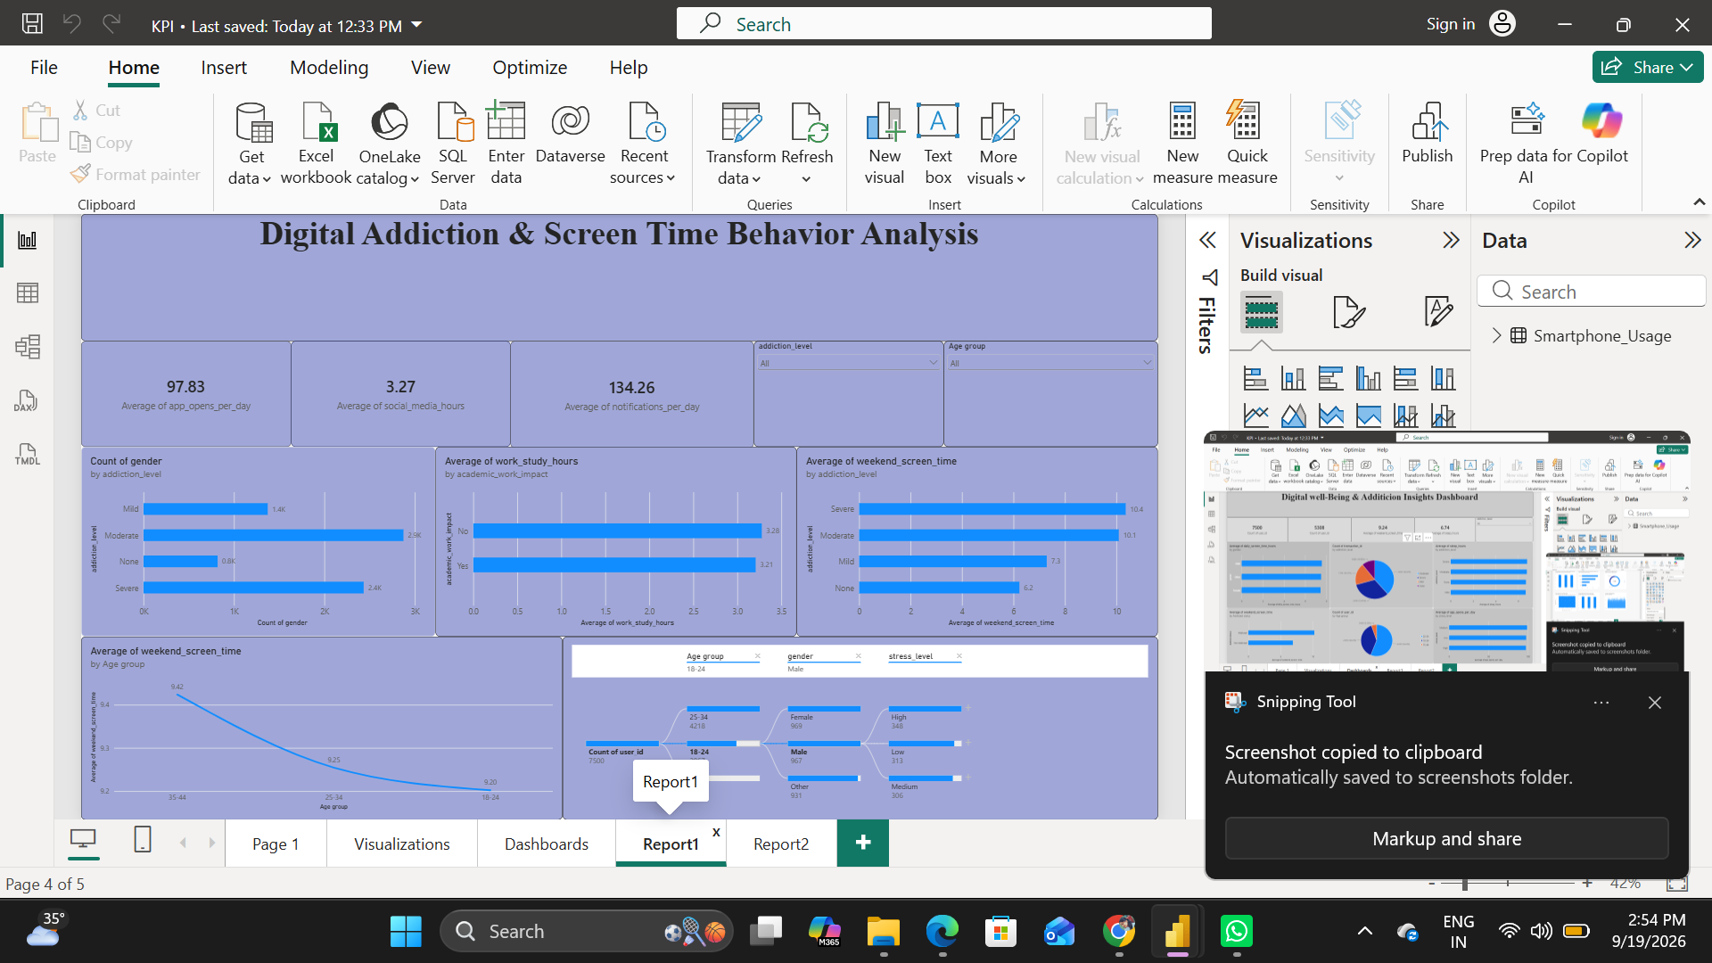
Figure 1: Power BI dashboard view – Smartphone usage and digital well-being analysis.
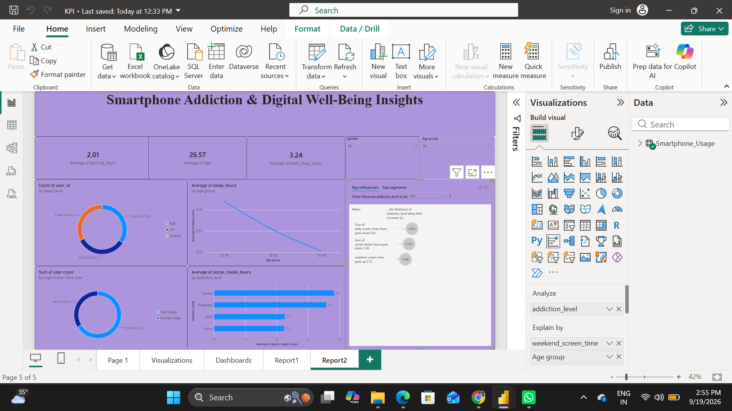
Figure 2: Power BI dashboard view – Smartphone usage and digital well-being analysis.

10. Conclusion

The Power BI dashboard provides a consolidated view of smartphone usage and digital well-being across 7,500 users. The most prominent indicators are high daily and weekend screen time, frequent app interaction, substantial notification volume, social-media and gaming usage, and variation in addiction levels. Together, these visuals provide a practical foundation for deeper behavioral analysis and for developing data-driven digital well-being interventions.

